**A rapid diagnostic bioassay to detect pyrethroid resistant mites in the field**

Introduction:

In Australia, a broad range of plants are fed on by the polyphagous redlegged earth mite (RLEM), *Halotydeus destructor* (Tucker)(Cheng et al. 2018b; RidsdillSmith 1997). RLEM annually undergoes 3-4 generations in the cool and moist period (Cheng et al. 2021b), but survives the hot and dry period as summer diapause eggs in the female cadavers (Cheng et al. 2018a; Cheng et al. 2019a; Ridsdill-Smith et al. 2005). Active mites attack plants of all growth stages, while the first generation of mites emerging after diapause cause greatest feeding damage because crop plants are at critical stages (seed germination or seedling establishment)(Cheng et al. 2021a).

Chemical control is the main method to protect crops from RLEM (RidsdillSmith 1997). Currently, only five mode-of-action groups of chemicals are registered to manage RLEM (Maino et al. 2021), including pyrethroids (Group 3A), organophosphates (Group 1B), neonicotinoids (Group 4A), fiproles (Group 2B), and diafenthurion (Group 12A). DDT (Group 3B) was used in a large scale between 1950s and 1970s through bare-earth treatments until it was banned and largely replaced by a pyrethroid chemical, bifenthrin in bare-earth treatments (RidsdillSmith 1997). Bifenthrin and other pyrethroids have been also used extensively through foliar sprays to manage RLEM (Ridsdill-Smith et al. 2008). However, both DDT and pyrethroids are modulators targeting the voltage-gated para sodium channel (VGSC) (Edwards et al. 2018). A long-term reliance on VGSC modulators has undoubtedly resulted in strong selection for a mutated VGSC with reduced sensitivity to VGSC modulators. Mutations on VGSC that contribute to cross-resistance against pyrethroids and DDT are found in many arthropods and known as knockdown resistance (*kdr*) mutation (Rinkevich et al. 2013). A *kdr* mutation, L1024F, was found in *H. destructor*, at the position 1024, whereby phenylalanine (F) is substituted for leucine (L) (Edwards et al. 2018). The pyrethroid-resistant population of *H. destructor* was firstly found at Esperance in Western Australia (WA) in 2006 (Umina 2007). Pyrethroid-resistant populations have now been found across the southern areas of WA and South Australia (SA) (Maino et al. 2018). Regarding L1024F, two mutated alleles (TTT and TTC) have been detected in resistant populations that are geographically separated, while one wildtype allele (TTG) has been found in susceptible populations (Yang et al. 2020).

RLEM reproduces sexually and both genders are diploid (Weeks et al. 1995). To investigate the dominance level of pyrethroid resistance in RLEM, Maino et al. (2021) tested four geographically-separated resistant populations have in bioassays with serial concentrations of bifenthrin between 0.0025-10000 mg/L, including the suggested field rate (100 mg/L, which is also a discriminating dose to detect resistant mites). The LC50 values of the susceptible homozygote (SS) and the heterozygote (RS) in all populations were less than 0.5 mg/L, while the LC50 values of the resistant homozygote (RR) in all populations are higher than 1000 mg/L (Maino et al. 2021), a result congruous with those of Cheng et al. (2019b). This demonstrates that the resistant mutation in RLEM is strongly recessive, providing an opportunity for resistance to be managed using unsprayed refuges to maintain the susceptible allele (Maino et al. 2021; Maino et al. 2019). After pesticide application, the few RR mites that survive in sprayed areas are expected to breed with SS mites from the refuge to produce controllable RS offspring. This refuge strategy to delay the evolution of resistance should be especially useful in initial stages when the frequency of the resistant allele is still low. If a population has a high resistant allele frequency, the application of pyrethroids should be stopped or replaced by alternative pesticides with different mode of actions (Cheng et al. 2021b). Pyrethroid resistance in RLEMis associated with fitness cost and therefore the frequency of the resistant allele will decrease through generations in the absence of pyrethroids (Cheng et al. 2021a).

The above strategies can only be implemented widely if there is an easy and rapid way of detecting resistant mites. Resistance in RLEM populations is typically assessed using phenotypic bioassays, a method that utilizes pesticide-coated vials first developed to test for tolerance to pesticides (Hoffmann et al. 1997) and subsequently used to screen for and detect resistance (Umina 2007, Umina et al. 2021). This bioassay technique is labour intensive and takes several days before a result is known; after mites have been collected from the field and stored at 4°C in the laboratory, vials for bioassays are coated with different concentrations of pesticide solutions on the first day. Then, vials are left upside down overnight on to air dry. Mites introduced into vials on the second day are scored for mortality, typically either 8h or 24h later. However, this assay can produce unreliable results when mites need to be shipped from the field to the laboratory for bioassays (Cheng et al. 2021a). In addition, the assay only detects surviving RR mites whereas RS and SS mites are both killed. Although molecular assays can be used to identify all three genotypes (e.g. Sanger sequencing, HRM genotyping, digital PCR) and applied to pooled samples (Cheng et al. 2021b; Cheng et al. 2019b; Edwards et al. 2018; Maino et al. 2021), genetic approaches can be expensive and also require shipment of mites to the laboratory where specialist equipment is available. On the other hand, a rapid phenotypic bioassay would be useful for growers and agronomists to monitor ongoing resistance evolution *in situ*. This paper describes such an assay that is capable of identifying RR mites.

**Material and Methods**

Mite collections and bioassays

Mites were collected with a blower vacuum () and using a metal cup of fine gauze mesh from a number of locations between July-September 2019 (Table 1) to test seven chemical products (Table 2) containing pyrethroids that are easily accessible to growers and agronomists. These locations consisted of five roadsides pastures, which were expected to have pesticide-susceptible populations, and six paddocks of agricultural properties, including two paddocks known to have pyrethroid resistant mites. Chemical products were intentionally covered a diversity of active ingredients and formulations (*i.e.* aerosols, granular products, and materials impregnated with the pesticide active ingredient). Several protocols were developed to suit the different products and applied to the various population samples, pending availability and the success of each protocol.

Table 1. Populations

|  |  |  |  |  |
| --- | --- | --- | --- | --- |
| Population No. | Location | Vegetation | Putative status to pyrethroids | Collection time |
| 1. Tintinara-R1 | Tintinara SA  (-35.947, 140.132) | A lucerne-dominated paddock | Resistance | Jul-Sep 2019 |
| 1. Tintinara-S1 | Tintinara SA  (-35.883, 140.061) | A roadside pasture dominated by grasses | Susceptible | Jul-Sep 2019 |
| 1. Epping | Epping, VIC (37.650, 145.034) | A roadside pasture containing clovers, grasses and capeweed | Susceptible | Jul-Sep 2019 |
| 1. Tintinara-R2 | Tintinara SA  (-35.954, 140.128) | A lucerne**-**dominatedpaddock | Resistance | Oct 2019 |
| 1. Tintinara-S2 | Tintinara SA  (-35.883, 140.061) | A roadside pasture containing clovers, grasses and capeweed | Susceptible | Oct 2019 |
| 1. Willalooka-1 | Willalooka SA (-36.353, 140.257) | A clover-dominated paddock | Unclear | Oct 2019 |
| 1. Willalooka-2 | Willalooka SA, (-36.353, 140.255) | A grass-dominated paddock | Unclear | Oct 2019 |
| 1. Keith | Keith, SA (36.100, 140.352) | A roadside pasture containing clovers, medicks, grasses and capeweed | Susceptible | Oct 2019 |
| 1. Kellalac | Kellalac, VIC (-36.386, 142.413) | A canola paddock | Unclear | Oct 2019 |
| 1. Toolondo | Toolondo, VIC (-37.005, 141.860) | A canola paddock | Unclear | Oct 2019 |
| 1. Rokewood | Rokewood, VIC (37.879712, 143.675344) | A roadside pasture containing clovers, grasses and capeweed | Susceptible | Oct 2019 |

Table 2

|  |  |  |  |  |
| --- | --- | --- | --- | --- |
| Product No. | Manufacturer | Active ingredient and pyrethroid types (I or II) | Formulation type | Tested populations |
| 1. Low allergenic fly & mosquito killer fly sprayers | Mortein | 2.41g/kg bioallethrin (I) | Aerosol | 1-2 |
| 1. Easy reach surface spray-cockroach killer | Mortein | 2g/kg cypermethrin (II) and 1g/kg imiprothrin (I) | Aerosol | 1-2 |
| 1. Low irritant surface spray crawling insect killer | Black & Gold | 2.79 g/kg permethrin (I) and 1.38 g/kg tetramethrin (I) | Aerosol | 1-2 |
| 1. Low irritant fly & insect killer | Black & Gold | 1.08g/kg tetramethrin (I), 0.25g/kg phenothrin (I) and 2.17g/kg piperonyl butoxide (synergist) | Aerosol | 1-2 |
| 1. Python insecticidal cattle ear tag | Y-Tex® | 100g/kg zeta-cypermethrin (II) and 200g/kg piperonyl butoxide (synergist) | Tag | 1 and 11 |
| 1. Ant killer powder | HOVEX | 10g/kg permethrin (I) | Granules | 1-2 |
| 1. Antex insecticide granules | David Grays | 2g/kg bifenthrin (I) | Granules | 1-10 |

For the aerosol products (Products 1-4), each product was sprayed into a disposable plastic food storage container (Coles, approximately 17cm long, 12 cm wide, 5.5cm high and 650mL) for approximately 5 seconds. Paper towel was then used to smear the chemical across the inner surface of the container and to remove any remaining liquid. The container was then air dried for 10 min. Approximately 20 mites were added to each container, which were sealed with a Coles cling wrap before being sealed with a lid. The cling wrap prevented mites hiding in space between the lid and container wall. Mite mortality scored every 15 min for one hour. The protocol was used on samples from two populations (Tintinara-S1 or Tintinara-R1) and repeated three times.

To test the Python insecticidal cattle ear tag (Product 5), we used two approaches, both utilising the Tintinara-R1 and Epping populations (Table 1). In the “no contact” approach, approximately 20 mites were introduced into a container and paper towel added on top of the mites in the container before the cattle tag was put on top of the paper towel and the container was covered with a lid. Mortality was observed every 15 min for one hour. In the “contact” approach, around 20 mites were introduced into a small plastic vial (15 mL) which was covered with a cattle tag and inverted. Vials were tapped manually to force the mites onto the cattle tag for 5 minutes. Then, the cattle tag was removed, and the vial sealed with a plastic lid before mortality was observed every 15 min for one hour.

For the twogranular products (Products 6 & 7 in Table 2), we undertook multiplebioassays with mite collections from populations 1 and 2 (Table 1). The bioassay involved three doses of granules and a control treatment. The doses consisted of 0.5g, 5g, or 30g of product added to a disposable plastic food storage container (Coles, approximately 17cm long, 12 cm wide, 5.5cm high and 650mL), while nothing was added in the control group. The 0.5g granule treatment covered around 5-10% bottom area of the container, while the 5g granule treatment covered approximately half area and the 30g granule treatment covered all of it. Tests were repeated three times, with approximately 20 adult mites added into the container in each repeat. Then, the container was sealed with a Coles cling wrap before being sealed with a lid. The cling wrap prevented mites hiding in space between the lid and container wall. Mortality was scored hourly for 3 h. The mites that walked freely were considered alive, while mites without movement or with inhibited movement were considered dead (Maino et al. 2021). Mites that survived after 3 h or that died were stored separately for molecular genotyping.

Product 7 proved to be successful in distinguishing RLEM that were putatively resistant and susceptible to pyrethroids. Thus, this product (involving the 0.5g bifenthrin treatment) was used to screen extra 8 populations (Populations 4-11 in Table 1) and the methodology was further refined. In Oct 2019, mites of Populations 1 (Tintinara-R1) and 2 (Tintinara-S1) disappeared, so the Population 4 (Tintinara-R2) was collected from another paddock next to Tintinara-R1 as a putative resistant population. In these assays, mortality was observed for 8 hour and a lucerne (*Medicago sativa*) branch with 4-5 leaves was added into each container to provide food and moisture for mites. Two populations (5 and 10 in Table 1) were also tested as controls (no granules). For each of four repeats, approximately 20 adults were added into the container which was then sealed with a cling wrap and a lid added. Mortality was observed once per hour for the first four hours and then after 6 and 8 hours. Following these assays, mites that died at 1h, 1- 3h, 3- 8h and mites that survived were separated for later genotyping.

DNA extraction and genotyping L1024F polymorphisms

In the 3h bioassay of 0.5g Product 7, 21 mites that were picked up from the Population 1 (table1), included 14 mites survived and 7 dead in the third hour, which were suspected to be resistant and susceptible genotypes, respectively. In the 8h bioassay of 0.5g Product 7, all mites that survived after 1h were suspected to contain pyrethroid resistant alleles and hence were genotyped. These mites were from four populations (4, 6, 7, 11 in Table 1), so a part of mites of these populations that died in an hour were suspected to be susceptible and genotyped. All mites of Populations (2, 3, 5, 8-10) died in an hour and were expected to be susceptible, so only 16 mites of the Population 5 were pick up and genotyped. Genomic DNA was extracted from individual mite of these samples using a modified Chelex extraction protocol and then L1024F polymorphism of each individual was identified with a modified HRM assay developed for a 58 bp amplicon containing the mutated position 1024 (Cheng et al. 2019b).

**Results and Discussion**

All products, except David Grays antex granules (Product 7) proved unsuccessful in this study. Products 1-4 and 6 killed 100% of RLEM, regardless of mite population within one hour. For Product 5, there was no mortality after one hour when there was no contact between mites and Python insecticidal cattle ear tag. Regardless of mite population, 100% of RLEM were killed in only 15 min when mites were forced to contact the Python insecticidal cattle ear tag.

When using David Grays antex granules in the three-hour bioassay, the mortality of Population 1 mites reached approximately 60% after 1 h regardless of bifenthrin dose (0.5g, 5g or 30g), and this remained constant after both 2h and 3h exposure (Figure 1). When mites were exposed to the same conditions in the absence of the granules, there was very low mortality (4% after 1h, 7% after 2h, and 16% at 3h). By contrast, the mortality of Population 2 mites reached 100% after one hour at each dose of bifenthrin tested (Figure 1). When mites were exposed to the same conditions in the absence of the granules, there was very low mortality (0% after 1 h, 2% after 2h, and 9% at 3h). The Once again, the mortality in the control treatment (*i.e.* in the absence of granules), remined low at all time points (4% after 1h, 7% after 2h, and 16% at 3h).

In the eight-hour bioassay (Figure 2), the Population 11 showed low mortality in the control treatment after 1 hour but this increased to 28% in the 8th hour, while granules killed 99% mites of Population 11 in the 1st hour and all mites were dead by the 2nd hour. All mites from four other populations (Populations 5 and 8-10) were killed by the granules in the 1st hour, so the mortality curve of these four population largely overlapped with Population 11’s curve. The granules killed 93% and 94% mites of Populations 4 and 7 respectively in the 1st hour and mortalities in these two populations rose to 99% between the 2nd and 8th hours. The mortality of Willalooka-R1 population in the control rose gradually from 5% in the 1st hour to 32% in the 8th hour, while granules killed 86% mites of this population in the 1st hour. The mortality of Willalooka-R1 population in the granule treatment rose gradually between 1 and 8 hours to 92%.

Of the 197 mites genotyped, there were 115 susceptible homozygotes (SS), 46 heterozygotes (RS) and 36 homozygotes (RR) (Table 3). Within an hour, the bifenthrin granules had killed 93% of the SS mites and 93% of the RS mites, but only 19% of the RR mites. Within three hours, the bifenthrin granules had killed 99% of the SS mites and all of the 100% RS mites, whereas 19% of the RR mites were still alive. After 8 hours, the bifenthrin granules had killed all SS and RS mites, but only 33% of the RR mites.

In the above tested products, David Grays Antex insecticide granules identified the resistant mites clearly and conveniently. The quantity of granules added for the bioassay could be very flexible because the mortality at the 3h bioassay between different quantities of granules (0.5-30g) were almost the same, but only differed between populations. We suggested to use 0.5 granules which only covered 5%-10% bottom area of the container and therefore mites can be observed easier. The 0.5g granules killed almost all mites of SS and RS, while the majority of RR survived with 3-8h bioassay.

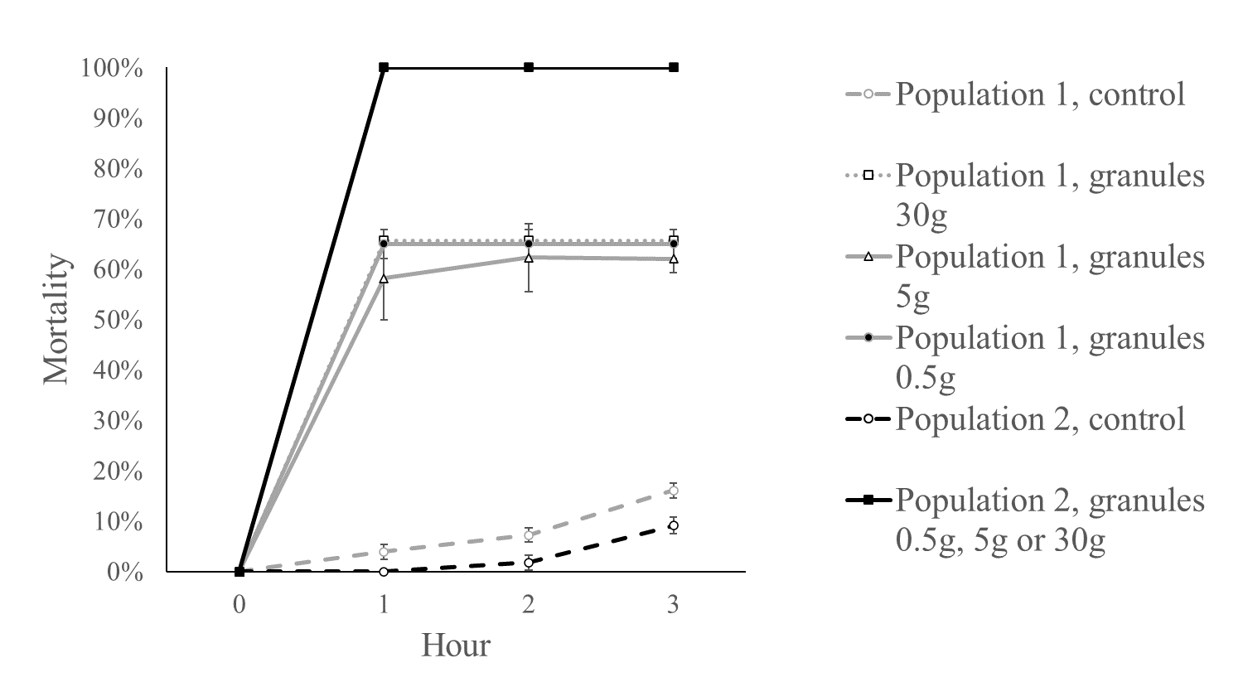

Figure 1. Three-hour mortalities of Populations 1 and 2 in the groups of control and three doses of bifenthrin granules. The mortality of Population 2 reached 100% in three doses of bifenthrin granules and therefore their curves are the same. Error bars are standard errors.

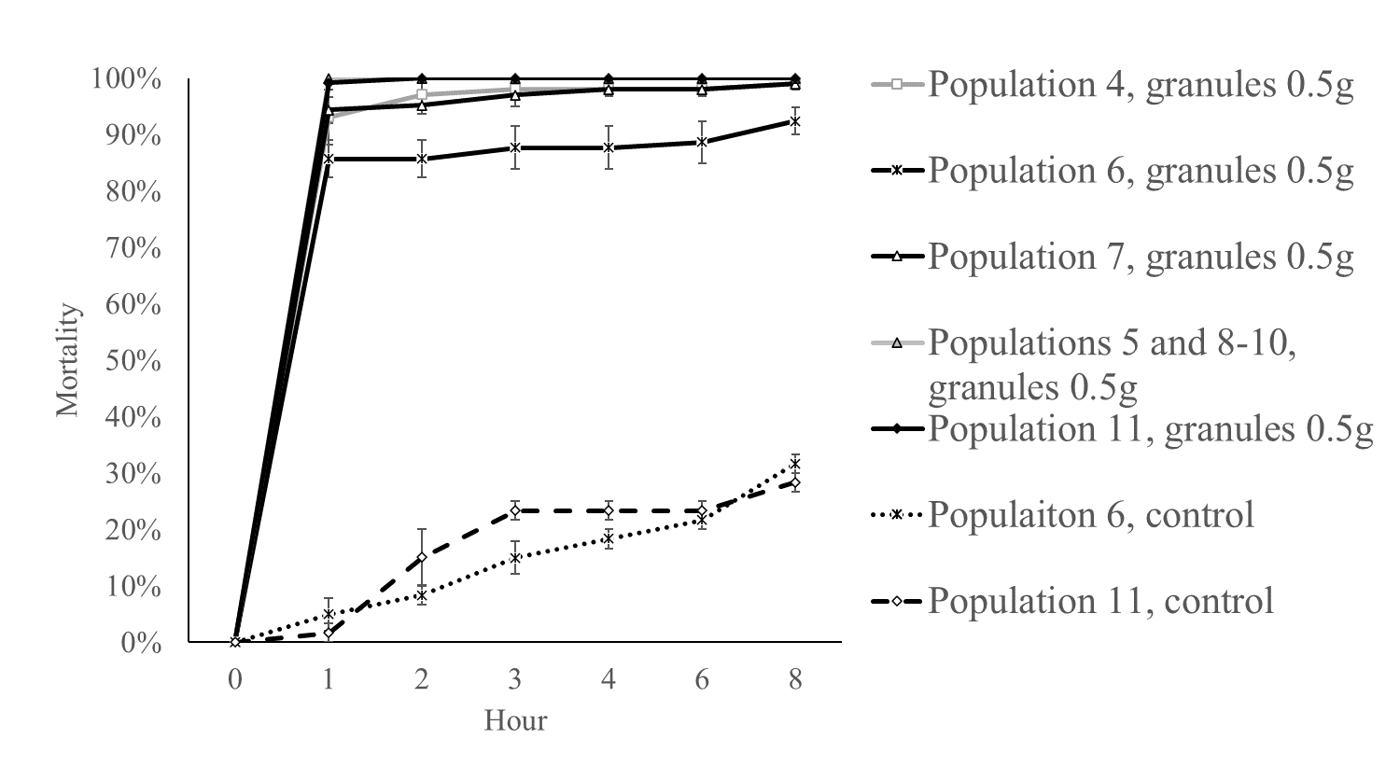

Figure 2. Eight-hour mortalities of five SA populations (Populations 4-8) and three VIC populations (Populations 9-11). In the bioassay of 0.5g granules, the mortality reached 100% in one hour in four populations (Populations 5 and 8-10) while the mortality of the Population 11 reached 99% in one hour and 100% in two hours, so the curves between these five populations largely overlapped. Error bars are standard errors.

Table 3. The genotypes of bioassayed samples from six populations (see Table 1 for population designations)

|  |  |  |  |  |  |  |  |  |  |  |  |  |  |  |  |
| --- | --- | --- | --- | --- | --- | --- | --- | --- | --- | --- | --- | --- | --- | --- | --- |
| 8h bioassay | Population 4 | | | Population 5 | | | Population 6 | | | Population 7 | | | Population 11 | | |
|  | SS | RS | RR | SS | RS | RR | SS | RS | RR | SS | RS | RR | SS | RS | RR |
| Dead in 1h | 20 | 13 | 0 | 16 | 0 | 0 | 24 | 0 | 0 | 24 | 11 | 0 | 23 | 0 | 0 |
| Dead between 1-3h | 2 | 3 | 0 | 0 | 0 | 0 | 1 | 0 | 0 | 3 | 0 | 0 | 1 | 0 | 0 |
| Dead between 3-8h | 1 | 0 | 0 | 0 | 0 | 0 | 0 | 0 | 4 | 0 | 0 | 0 | 0 | 0 | 0 |
| Alive at 8h | 0 | 0 | 1 | 0 | 0 | 0 | 0 | 0 | 8 | 0 | 0 | 1 | 0 | 0 | 0 |
| 3h bioassay | Population 1 | | |  |  |  |  |  |  |  |  |  |  |  |  |
|  | SS | RS | RR |  |  |  |  |  |  |  |  |  |  |  |  |
| 3h dead | 0 | 19 | 7 |  |  |  |  |  |  |  |  |  |  |  |  |
| 3h alive | 0 | 0 | 14 |  |  |  |  |  |  |  |  |  |  |  |  |

**REFERENCES**

Cheng, X, Hoffmann, AA, Edwards, OR & Umina, PA. 2021a Fitness Costs Associated with Pyrethroid Resistance in *Halotydeus destructor* (Tucker)(Acari: Penthaleidae) Elucidated Through Semi-field Trials. *Journal of Economic Entomology*.

Cheng, X, Hoffmann, AA, Maino, JL & Umina, PA. 2018a A cryptic diapause strategy in *Halotydeus destructor* (Tucker) (Trombidiformes: Penthaleidae) induced by multiple cues. *Pest Management Science* **74**, 2618-2625.

Cheng, X, Hoffmann, AA, Maino, JL & Umina, PA. 2019a Summer diapause intensity influenced by parental and offspring environmental conditions in the pest mite, *Halotydeus destructor*. *Journal of Insect Physiology* **114**, 92-99.

Cheng, X, Umina, PA, Binns, M, Maino, J, Ghodke, A & Hoffmann, AA. 2021b Options for managing pesticide resistance in the redlegged earth mite (*Halotydeus destructor* Tucker): an experimental test involving altered selection pressures and alternative chemicals. *Crop and Pasture Science* **In Press**.

Cheng, X, Umina, PA & Hoffmann, AA. 2018b Influence of previous host plants on the reproductive success of a polyphagous mite pest, *Halotydeus destructor* (Trombidiformes: Penthaleidae). *Journal of Economic Entomology* **111**, 680-688.

Cheng, X, Umina, PA, Lee, SF & Hoffmann, AA. 2019b Pyrethroid resistance in the pest mite, *Halotydeus destructor*: Dominance patterns and a new method for resistance screening. *Pesticide Biochemistry and Physiology* **159**, 9-16.

Edwards, OR, Walsh, TK, Metcalfe, S, et al. 2018 A genomic approach to identify and monitor a novel pyrethroid resistance mutation in the redlegged earth mite, *Halotydeus destructor*. *Pesticide Biochemistry and Physiology* **144**, 83-90.

Hoffmann, AA, Porter, S & Kovacs, I. 1997 The response of the major crop and pasture pest, the red-legged earth mite (Halotydeus destructor) to pesticides: dose-response curves and evidence for tolerance. *Experimental & applied acarology* **21**, 151-162.

Maino, J, Hoffmann, AA, Binns, M, Cheng, X & Umina, PA. 2021 Strip spraying delays pyrethroid resistance in the management of the redlegged earth mite, *Halotydeus destructor*. *Pest Management Science* **77**, 4572-4582.

Maino, JL, Binns, M & Umina, P. 2018 No longer a west-side story–pesticide resistance discovered in the eastern range of a major Australian crop pest, *Halotydeus destructor* (Acari: Penthaleidae). *Crop and Pasture Science* **69**, 216-221.

Maino, JL, Renton, M, Hoffmann, AA & Umina, PA. 2019 Field margins provide a refuge for pest genes beneficial to resistance management. *Journal of Pest Science* **92**, 1017-1026.

Ridsdill-Smith, J, Pavri, C, De Boer, E & Kriticos, D. 2005 Predictions of summer diapause in the redlegged earth mite, *Halotydeus destructor* (Acari: Penthaleidae), in Australia. *Journal of Insect Physiology* **51**, 717-726.

Ridsdill-Smith, TJ, Hoffmann, AA, Mangano, GP, Gower, JM, Pavri, CC & Umina, PA. 2008 Strategies for control of the redlegged earth mite in Australia. *Australian Journal of Experimental Agriculture* **48**, 1506-1513.

RidsdillSmith, TJ. 1997 Biology and control of *Halotydeus destructor* (Tucker) (Acarina: Penthaleidae): A review. *Experimental and Applied Acarology* **21**, 195-224.

Rinkevich, FD, Du, Y & Dong, K. 2013 Diversity and convergence of sodium channel mutations involved in resistance to pyrethroids. *Pesticide Biochemistry and Physiology* **106**, 93-100.

Umina, PA. 2007 Pyrethroid resistance discovered in a major agricultural pest in southern Australia: the redlegged earth mite *Halotydeus destructor* (Acari: Penthaleidae). *Pest Management Science* **63**, 1185-1190.

Weeks, AR, Fripp, YJ & Hoffmann, AA. 1995 Genetic structure of *Halotydeus destructor* and *Penthaleus major* populations in Victoria (Acari: Penthaleidae). *Experimental and Applied Acarology* **19**, 633-646.

Yang, Q, Umina, PA, Rašić, G, et al. 2020 Origin of resistance to pyrethroids in the redlegged earth mite (*Halotydeus destructor*) in Australia: repeated local evolution and migration. *Pest Management Science* **76**, 509-519.